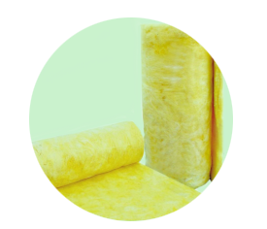
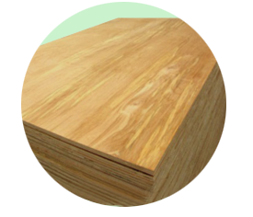
EcoSynthetix is a global technology leader focused in the biopolymer market space. With its Center of Innovation located in Burlington, Ontario (Canada), we provide renewable, environmentally-friendly alternatives to traditional petroleum-based binder materials that are entrenched in many of today’s industrial and consumer products across a multitude of markets including building & construction, personal care, packaging, paints & coatings, and numerous others.

So, why even consider change?
- We can meet your performance needs. EcoSynthetix has successfully developed and commercialized many new products to displace styrene-butadiene or other traditional petro-based binder materials that deliver end-product performance requirements.
- We can help you meet your sustainability objectives. EcoSynthetix delivers sustainable polymers for planet earth^{tm}; independent third party cradle-to-gate lifecycle assessments have demonstrated that our products can reduce carbon footprint up to 67% vs. comparable petro-based incumbents.
- It doesn’t need to cost more. Not being based on volatile crude oil feedstocks can be a very good thing. We can help by offering attractive overall economics with stable and predictable pricing.
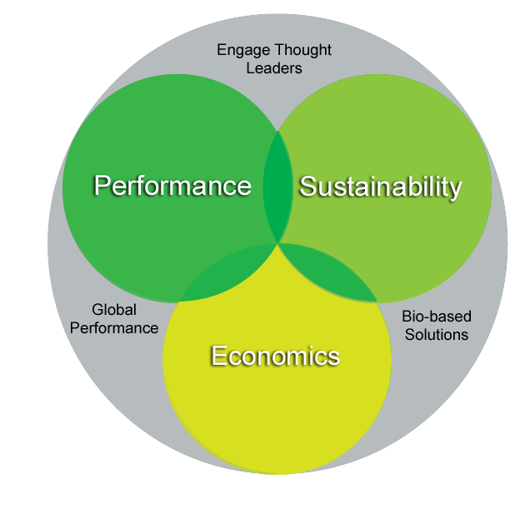
To learn more, visit www.ecosynthetix.com

